**AIRBNB PRICE OPTIMIZATION & USER RECOMMENDATION APPLICATION**

*Khozema Lokhandwala - +1(617) 602-6983*

**INSTALLATION OF GEOQLIK FOR QLIK SENSE**  
Download the GeoQlik extension for Qlik Sense using the link below:

<https://www.geoqlik.com/en/resources/trial-versions.html>

Complete the setup and ensure your Qlik directory C:\Users\USERXYZ\Documents\Qlik\Sense\Extensions has the GeoQlik folder with all the files.

This is extension is required to view the map present in my dashboard. GeoQlik allows greater flexibility and more options for customization when working with maps on Qlik Sense. In my Dashboard, I have utilized GeoQlik to customize the tool-tip to show a chunk of relevant information which is otherwise not possible with the built-in maps of Qlik Sense.

A screenshot of how it looks on my dashboard-“Airbnb Price Optimization & User Recommendation App - WIT project” is shown below:

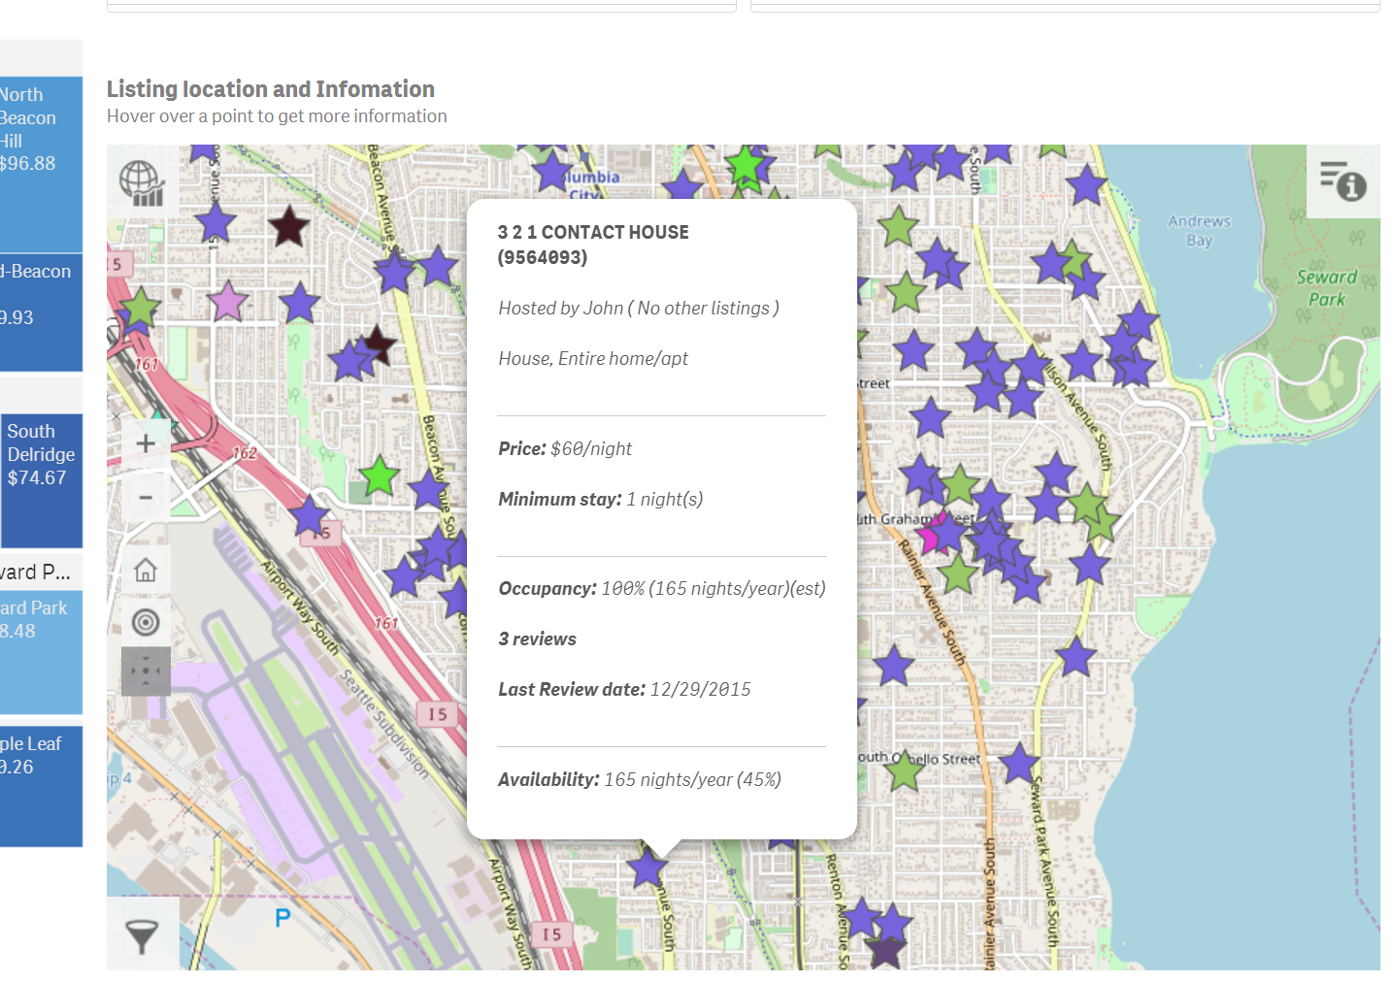

**USING THE QVF FILE**

Please place the `WIT Project-Khozema.qvf` file in Qlik Apps directory of your system.

C:\Users\USERXYZ\Documents\Qlik\Sense\Apps

Now you will be successfully able to load the application complete with all the data & visualizations.

DATA SOURCES

The data sources used for this project are:

1. listings finale.xlsx
2. Hosts cleansed.xlsx
3. calendar final.xlsx
4. crime_data.sql
5. Neighborhood.xlsx

Data sources 1, 2 & 3 were obtained from an open source community data sharing website called Kaggle.

The link for the same is <https://www.kaggle.com/airbnb/seattle>

Data source 4 – `crime_data` was obtained from the official government website for seattle (link below):

<https://data.seattle.gov/Public-Safety/Seattle-Police-Department-Police-Report-Incident/7ais-f98f>

Data was stored into a mySQL database on the localhost sever since it was too big for Excel to handle. Later the sql file was connected to Qlik Sense using the ODBC connector for data import.

Data source 5 `Neighborhood` was a dummy table used to map Seattle neighborhoods to crime reporting area codes. This excel worksheet is not directly used in the dashboard.

Final submission is a zip file `WIT project-Khozema.zip` which includes the following files:

1. listings finale.xlsx
2. Hosts cleansed.xlsx
3. calendar final.xlsx
4. crime_data.sql
5. Neighborhood.xlsx
6. GeoQlik for Qlik Sense 2.2.1 Trial version (Setup file for the GeoQlik extension for quick setup)

Please feel free to reach out for any questions/concerns or problems with application initialization.